e-Course Dispatcher Training

Introduction:
Customer service and dispatching functions must work together to insure customer satisfaction

One primary CSR function is to keep schedules full by scheduling appointments
  - Promptly responding to customers when demand is high
  - Contacting customers to keep schedules full when demand is low

Primary functions of the dispatching process is to profitably manage schedules
  - Insure that appointments are assigned to the proper person
  - Assure that each call is efficiently completed to final disposition

The Customer Service and Dispatching functions must work together to
  - Insure 100% customer satisfaction
  - Develop long term loyal customers

The Dispatcher has a major impact on the service department’s efficiency and profitability. Consequently, the Dispatcher function is imperative to success.
It plays critical parts in the overall success of service department.

Minimum job requirements of an effective Dispatcher are:
- Possess the ability to think several moves in advance like a chess player.
- A calm and courteous demeanor.
- Computer data entry skills.

Basic job functions are:
- Selecting and routing technicians to maintenance and demand service calls efficiently and productively.
- Ensuring quality customer service.
- Prompting customers for maintenance agreements.

Responsibilities:
- Provide a positive and winning attitude at all times.
- Always treat customers and coworkers with dignity and respect.
- Handle customers with courtesy and professionalism.
- Ensure proper communication between customer service representatives, maintenance technicians and service technicians.
- Daily determination of Service Mode: (Red, Yellow or Green).
- Ensure proper communications between the customer and the maintenance and service technicians.
- Ensure that payment in full is made on each and every maintenance and service call prior to technician leaving the home.

Principal duties:
- Routing maintenance and service technicians based on technician skill level, geographic efficiency and customer satisfaction.
- Briefing technicians on the who, what, why, where and how of the call you are dispatching them to.
- Maintaining the maintenance and service dispatch board.
- Communicating to all customers the estimated arrival time of the technicians.
- Keeping all customers apprised well in advance of any potential for their appointment being pushed back.
- Debrief all technicians after every call to ensure proper customer satisfaction, follow-up requirements, data entry, warranty parts and truck stock used and needed for replenishment.
- Provide a list of parts and filters necessary for the following day to the warehouse/inventory control or to be pulled for each technician.
- Keep track of the whereabouts of everyone in the company, how they can be reached and when they will return to the office.
- Participate in all company meetings.
- Establish and maintain a working knowledge of the industry.

Standards and measurements of performance:
- Ensuring a minimum of 75% efficiency for technicians.
- Number of service calls booked measured against benchmark.
- Number of maintenance calls booked measured against benchmark.
- Number of sales leads book measured against the benchmark.
- 90% of all incoming calls converted to schedule appointments.
- 100% of all customer concerns/issues/complaints are resolved or updated by the end of every day.

Dispatcher Training
Lesson 1: Strategic Processes and Planning

Objectives:
After completing Lesson 1 you will:
- Have a better understanding of the Dispatchers role
- Understand the Residential HVAC Retail business model
- Understand key strategic planning processes for dispatching

Key Strategic planning processes for Dispatch / Service Management
- Understanding of the residential retail business model
- High demand scheduling process (Code Red).
- First and second shift demand service process.
- On-call process.
- Low demand scheduling process (Code Yellow and Green).
- Determining Service and Maintenance production capability.
- Projecting Service and Maintenance minimum monthly revenue targets.
- Establishing stretch targets for demand months.
- Establishing minimum monthly KPI’s for Demand Service and Maintenance
- Action planning the implementation process.

Residential retail HVAC Business Model:

The HVAC business is a weather driven business. When the weather is extreme, incoming requests for service and new comfort systems are usually high.

On the other hand when the weather is mild, the incoming requests for service or new comfort systems are low.

This strategic planning session is designed to make your company less dependent upon the weather by filling 85% of the schedule during the slow season 6 to 8 months in advance and ensuring that your service department is available and accessible during demand season.

Let's take a closer look of a typical business cycle.

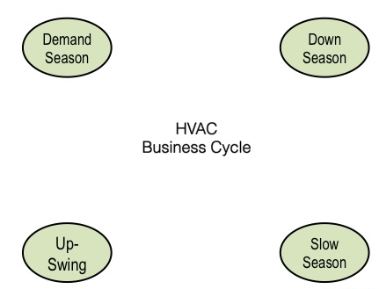

As you can see there are four cycles: demand season, down season, slow season, and an upswing season.

During the demand season customers are proactively calling us due to a high demand for heating and air-conditioning. This is usually when the weather is extreme extremely warm or extremely cold. HVAC equipment is working overtime to keep up and as a result, the demand for repairs and equipment replacement is extremely high.
Incoming call volume is usually very high.

The best approach for the demand season is to ensure that your company is accessible, available in prompt and serving your customers needs, acquiring new customers in creating slow season appointments by involving them with preventative maintenance agreements.

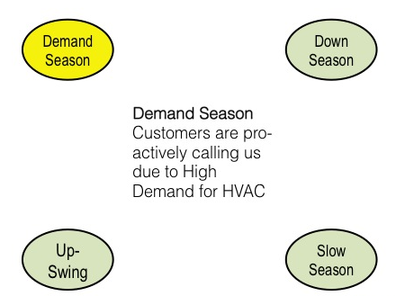

A down season is right towards the end of high demand season. For example, let's say it's the middle of summer the weather was extremely warm. The hottest day of the summer was 105° and three weeks later the 15 day Outlook is predicting an average high temperature of 82° with low humidity.

Fall is right around the corner, the demand for HVAC is slowing down, and the incoming calls for service is half the volume it was three weeks ago.

You have enough follow-up work to keep the schedule 50 to 60% full however, the weather will not be driving business for several months to come and customers are less responsive to advertising for heating and air conditioning products or services..

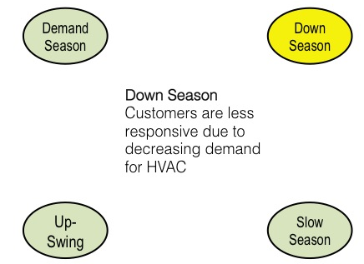

Slow season is best defined as Chamber of Commerce weather. Thermostats are turned off, windows are open and there is no demand for your products or services right now.
Another slow season scenario might be the holiday season, major local events or anything else that competes for your customers attention and motivation.

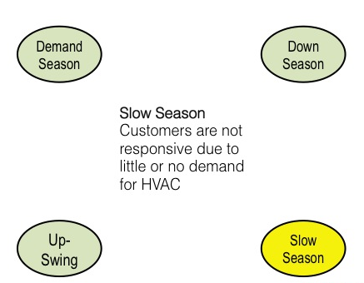

The upswing season is that time of year right before demand season. An example would be in the fall when people are getting ready for the winter so they may be receptive to equipment tune ups where we would visit them to make sure that their heating system is prepared for the heating season. Another example might be the springtime, getting ready for the summers hot and humid by making sure their air-conditioning system is in proper working order. Customers tend to be responsive to advertising that speaks to being prepared for the demand season.
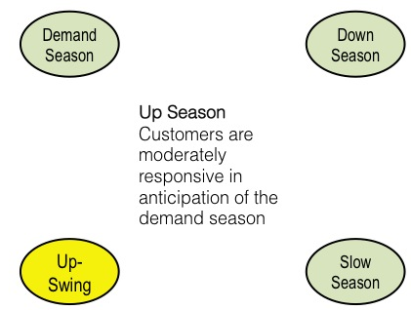

During both the upswing season and demand season the incoming call volume for products and services that HVAC companies offer is relatively high. Often times the schedule can be completely filled with incoming calls depending upon the weather.

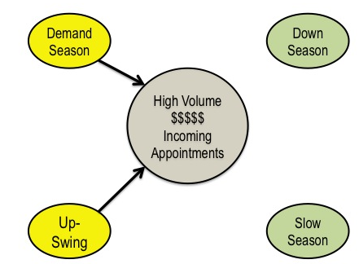

Customers will typically call requesting several different things during the upswing and Demand such as preventative maintenance to get their equipment ready for the demand season, repairing broken equipment, getting an estimate to replace old broken equipment with new equipment and additional services such as accessories, duct cleaning, air sealing and a whole menu of additional services your company may provide.

Your best approach to capitalize on the upswing and demand season is to be responsive and available by being attentive to your customers needs how and when they want your service.

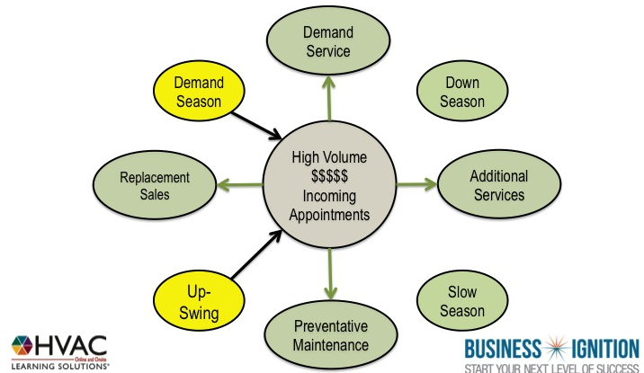

The down and slow season is a little more challenging. Customers are less responsive to advertising because the demand for heating and air-conditioning simply isn't there. The best approach for these months is to make your company less dependent on the weather to drive business by pre-scheduling enough work to keep the service schedule 85% FULL during the slowest months of the year.

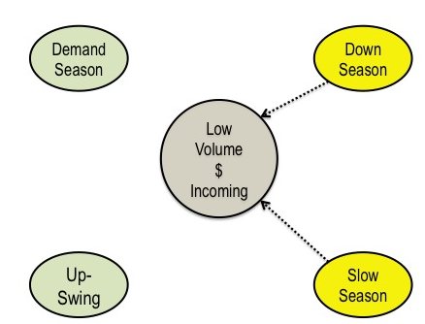

The incoming call volume from your customers can decrease by as much as 80% compared to demand season months. Proactively keeping service and replacement pipeline full of future work in preparation for this cycle is the best way to keep your team in front of customers.

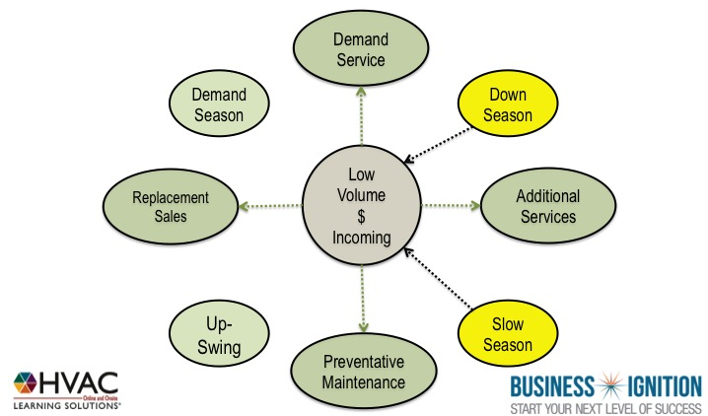

During the upswing and demand season when customers are scheduling demand service calls, preventative maintenance calls, requesting additional services or wanting an estimate to replace their heating and air-conditioning system

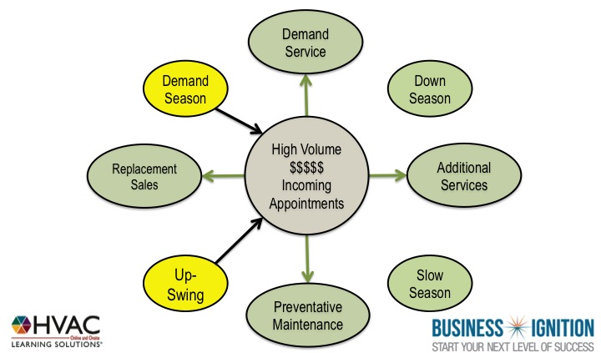

Keep your pipeline of future work full by involving those customers with preventative maintenance agreements. Preventive maintenance agreements ensures to future prepaid preventive maintenance calls.

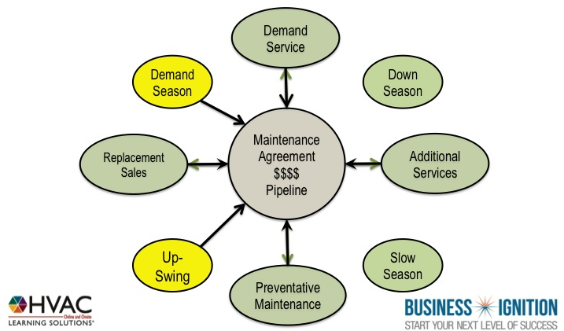

With this strategy, your company will be accessible and available for the very low volume of incoming calls as well as put you in a position to proactively schedule preventative maintenance work to offset the lack
of work due to the lack of weather.

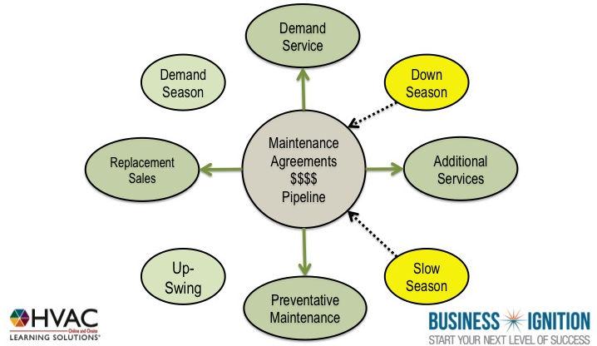

Properly trained service and maintenance technicians can generate some impressive results as long as they are In front of customers. For example, 10% of all demand service or service agreement calls with generally turn into a replacement lead. Replacement leads generated from service technicians typically close 85% of the time with higher margins.

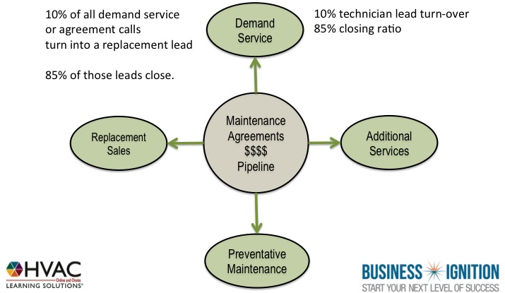

25% of preventative maintenance agreement calls for open tune-up calls generally turn into additional services such as preventive repairs, duct cleaning, air sealing and accessories such as thermostats, high-efficiency air filters, humidifiers, dehumidifiers and the list goes on.

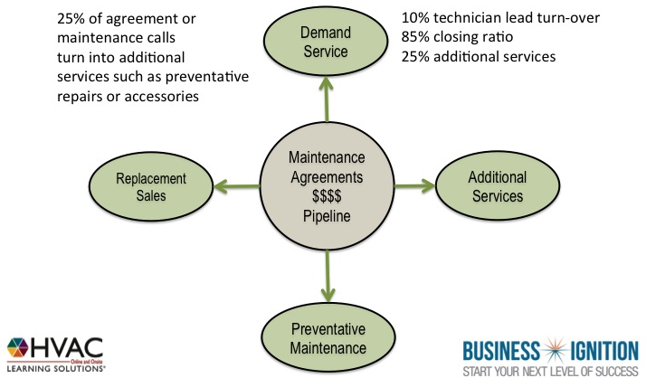

The exciting thing is preventative maintenance agreements are generally paid in advance. So every preventative maintenance service call that's completed is paid in full in the months when heating and air-
conditioning companies typically have no work.

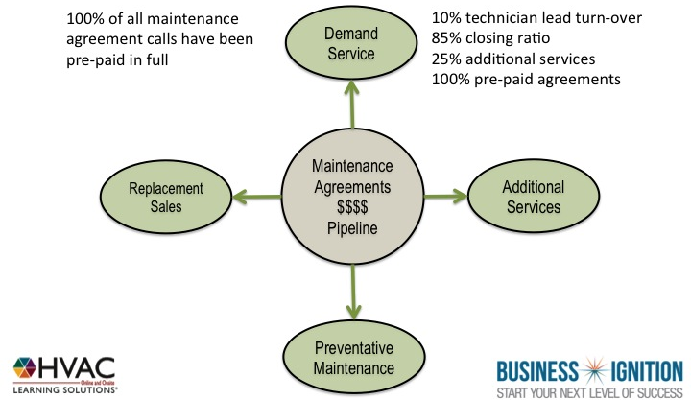

On average, a technician following this process will generate eight replacement leads each month resulting in six or seven replacement jobs, generate 20 additional services and complete $5,000.00 to $7,000.00 worth of prepaid agreements during the slowest months of the year.

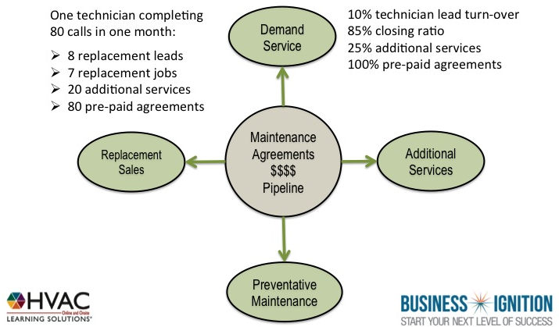

That one service technician operating under this premise would contribute anywhere from $50-$60,000 in revenue during the slowest months of the year, consistently.

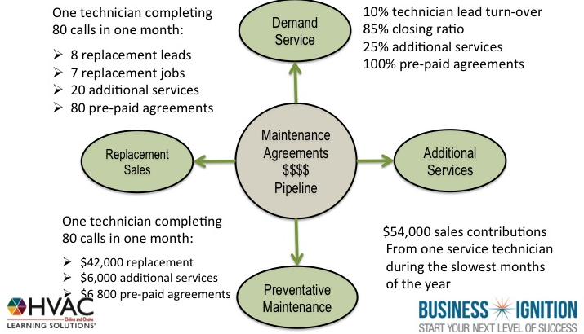

Strategy
Upswing & Demand Season

Sell enough future maintenance visits to keep your Technicians in front of 4 to 5 customers per day during The slower months.
- Generate 80% of replacement leads from Service & Maintenance calls.
- Maintain a 75% or better efficiency ratio.
- Bill out 5 dollars for every 1 dollar paid in service labor (minimum).
- Convert 2 out of 4 or more service calls to agreement customers.

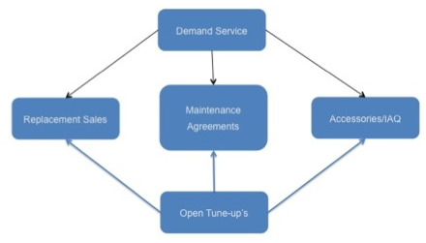

Strategy
Downswing & Slow Season
Keep Technicians in front of 4 to 5 customers per day.
- Generate 80% of replacement leads from Service & Maintenance calls.
- Maintain a 75% or better efficiency ratio.
- Bill out 5 dollars for every 1-dollar paid in service labor (minimum).
- Convert no less than 90% of agreement renewals upon last visit.

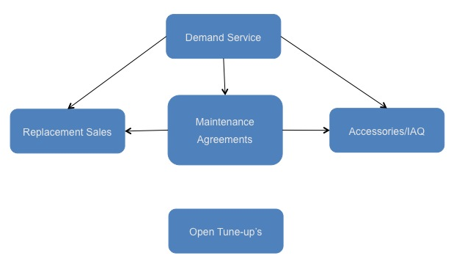

High Demand Scheduling Process (Code Red).

Service High Demand Protocol example:

Objectives:
1. Deliver exceptional Service.
2. Maximize opportunities.
3. Work Smart.

Pre-CODE RED strategy
Answering the demand service phone when the schedule is full:

Strategy:
1. Prioritize the calls.
2. Capture customer information.
3. Schedule every call in order of priority.
4. Put customers that are priority three or lower on a stand by list.
4. Follow up with every customer on stand by list every 3 hours.
5. Work prioritized calls into the schedule as schedule permits.
6. Influence maintenance agreement sales to non-maintenance agreement customers.
7. Reinforce the value of maintenance agreements to agreement holders.

Approach:
1. Keep your composure.
2. Remain Calm.
3. Refrain from announcing how “busy” or “Over-Booked” the schedule is.
4. The most important call is the one you are involved with at the time.

Call Prioritization: Non functioning systems
Priority 1:
- Equipment over 10 years old
- Our installs under warranty
- Agreement customers
- Health related issues
Priority 2: Equipment (7-10 years)
Priority 3: Equipment under 7 years (Active customer)
Priority 4: Equipment under 7 years (Non active customer)
Priority 5: Functioning equipment requesting general maintenance.
*** Unless you have a separate maintenance staff ***

CSR example Quick Script:

Thank You for Calling
(Your Company name), This is (state your Name) How can I help you?
OK, you say that your air conditioner isn’t working, is that correct?
Call Prioritization: Non functioning systems
Priority 1:
- Equipment over 10 years old
- Our installs under warranty
- Agreement customers
- Health related issues

Priority 2: Old Equipment (7-10 years old)

Priority 3: Equipment under 7 years
(Active customer)

Priority 4: Equipment under 7 years
(Non-active customer)

Priority 5: Functioning equipment requesting general maintenance
*Unless you have a separate maintenance staff
We can help you with that.

I just need some information:
- Your Name?
- Best number to reach you?
- Address?
- E Mail Address?
- Do you have a maintenance agreement with us?
- How old is your system?
- Any health related issues?

Thank you.

(Priority 1 or 2 customers)

What I can do is…

Route the next Technician in your area your way. They may be (a few hours out), what’s the best method for me to contact you to keep you posted on his ETA?

There will be a (----) minimum service fee to diagnose your system and quote the repair. Once approved, our technician will complete the repair.

Will you be paying by check or credit card?
Thank You.

(Non-agreement customer)
Be sure to ask our Technician
how you can save 15% off of your repair.

(Priority three or lower)

What I can do is…

“Put you on our stand by list and work you in when we have a technician in your area between calls. What is the best number to reach you at?

There will be a (----) minimum service fee to diagnose your system and quote the repair. Once approved, our technician will complete the repair.
Will you be paying by check or credit card?
Thank You.

Non-agreement customer
Be sure to ask our Technician
how you can save 15% off of your repair.

We will be staying in touch
with you at this number throughout the day to keep you posted on the schedule
What method of communication do you prefer? Text, e mail or phone?

Is there anything else I can help you with right now?

Thank you for choosing _______ heating and Cooling. We will be contacting with your schedule update with three hours.”

Following up with the “Stand By” list:

It is important to stay in contact with the “stand by” list every three to four hours. When scheduling the call, document the method of updates they would prefer: Phone call, e-mail or text. Clarify with the customer that you will nee confirmation of their availability with in 5 or 10 minutes of the call or you will have to route the technician to the next person in line. This would be the perfect opportunity to connect them to your company Facebook page and plant the seed for maintenance agreements.

Some Companies use this strategy to influence the purchase of maintenance agreements. When you review the status of their call, remind them of how the calls are prioritized: Health and safety, Agreement customers and systems under warranty. When you get a break in the schedule you can work them in. Depending on the call profile, you might consider moving them up on the list with the purchase of a maintenance agreement.
Incorporating a second or third shift with your Technicians will increase your ability to acquire more customers dramatically. (more on that later)

Customer Service and Dispatching High Demand time commitment (Code Red) Strategy:

Committing to a time of arrival for Technicians can be tricky, especially during peak demand season. It is important to focus on what you CAN DO for customers, not what you cant. The following will outline an effective method that when implemented will deliver an exceptional customer experience.

Effective communication between Customer Service, Dispatch ant Technicians is critical. Customer Service must be constantly updated on schedule availability, Dispatch must be updated on priority stand by calls and Technicians must report call status to the dispatcher 45 minutes into each call, giving the Dispatcher ample time to make adjustments to the schedule.

- Establish a time of arrival for first call with your technicians,
in this example, we will use 8:00 am as a standard.

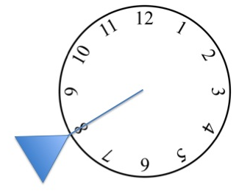

- Next, block out three-hour intervals for completion of calls. In this
Example, we will use 8:00 to 11:00; 11:00 to 2:00; 2:00 to 5:00; and after 5.

- The following 2-hour time commitment windows should overlap each completion time Benchmark by 1 hour. The example below illustrates an arrival time of 8:00 am for 1st call, 10:00 to 12:00 arrival window for second call, 1:00 to 3:00 arrival time for third call, 4:00 to 6:00 arrival time for fourth call and last call after 6:00pm.

- The next step is to insure each Technician reports the call status
with-in the first 45 minutes of arrival. That will give you (the dispatcher)
enough time to make necessary adjustments to the schedule.

- Assuming the average Demand Service call takes 2 hours including travel, this process allows flexibility to accommodate for calls that may take longer as well as the ability to “work priority stand-by calls into the schedule”.

1st, 2nd or 3rd Shift considerations.

There are several advantages to scheduling service Technicians in “shifts”. This is especially true with the residential retail model where being available and accessible to customers when they want you is a priority.

Weather your Company has a small blended service and maintenance department with 3 or 4 Technicians or your Company is larger with separate Service and Maintenance departments, scheduling the field in shifts has many advantages.

Benefits of a 1st, 2nd or 3rd “shift”:
- Ability to serve more customers at their convenience.
- Quicker follow through with return with parts repair calls.
- Ability to tighten up end of the day “loose ends”.
- More responsive to “High Priority” stand by calls.
- Less Technician fatigue.
- More time options for customers to choose from.
- Less of an inconvenience for homeowners.
- Better management of “After Hour Calls”.
- More effective labor control.

Smaller Service departments with two or three Technicians might want to consider blending the “shift” concept into their “On Call” rotation where the person on-call would begin their “shift” at 1:00 pm and complete scheduled calls through 8:00 p.m. The likelihood of emergency service calls after 10:00 p.m. is relatively low unless the weather is extreme. This strategy will also minimize the “On Call Fatigue” created when Technicians are required to work around the clock. Crisp, Clean and Sharp Professional Technicians ready to serve on every call, day or night is the goal.

Code Red, Yellow and Green Benefits

The benefits of having scheduling guidelines tied to a “Code Red, Yellow or Green” is that once everyone understands the protocol of the codes, all the lead Dispatcher or acting Sales manager has to do is communicate what “code mode” Customer service, Dispatch and Field service technicians are in. As long as everyone follows protocol, the team shifts into the appropriate gear quickly and efficiently. “High Demand” would be considered a Code Red protocol and
“Code Green” would be considered a Low demand protocol. A Yellow protocol would speak to the shoulder months leading into or out of the Demand months.

Low demand scheduling process
(Code Yellow and Green).

A Code Green protocol supports all the actions necessary to:
- Keep the Service Team in front of customers during the slowest times of the year.
- Manage labor
- Monitor Key Performance Indicators closely

Keeping the Service Team in front of customers during slower times:

Step 1:
Any incoming call requesting service gets scheduled. Fill the schedule.
Each Technician should be scheduled with a minimum of four services or maintenance calls by 2:00 p.m. the day before. Make everyone aware, track and post updated results in a visible area, focus on the goal, involve the entire Dispatching and Customer Service Team, have some fun and get it done.

Step 2:
Pre-schedule 75% of the service and maintenance departments schedule with maintenance agreements

Determining how many pre-scheduled agreements should be scheduled into slow months:

Typically, the minimum amount of calls you want to keep on a Technicians schedule each workday is 4. To determine how many maintenance agreements should be scheduled in a slow month, multiply the number of technicians by the minimum number of calls per day and multiply that number by working days in the month.

Example:
4 technicians
X 4 calls per day
= 16 calls per day
X 20 days
= 320 agreement calls pre-booked for the month.

The right time to pre-plan, sell and schedule maintenance agreements is during demand months and the shoulder months leading into demand months where there are plenty of opportunities to sell agreements to open tune up and Demand Service customers. Establish how many additional agreements need to be sold and scheduled to fill 80% of the slow season schedule and 60% of the shoulder months leading to the slow season. Compare daily, monthly and YTD results against your targeted benchmark and get it done.

Step 3:
Review old service tickets and Service proposals.
Make outbound calls to open Service proposals and influence customers to schedule the work.

Suggested Script: “Good afternoon, this is Tom from HLS Heating & Air-conditioning, Joe, our Technician completed a service call at your home a couple of months ago. Was Joe able too resolve everything to your satisfaction?”
Listen closely, If they were not satisfied, resolve the issue…
Assuming they were satisfied… go to the next step..

“Great! Joe does a great job, our customers really like him. I also noticed that he recommended some additional repairs to do >>>>>>>> What are your thought on scheduling the work?”

Step 4:
Go through all of your inactive customer files and “Dial for Tune-ups”.
Script:

“Mrs Smith? This is Tom from HLS Heating and Cooling” did I catch you at a good time this afternoon?
Our records indicate that its time to schedule a tune up for your (heating/cooling system). What are your thoughts on having Joe drop by after his 1st call next Thursday and take care of that for you? I’ll even throw in a $5.00 coupon for you, dropping your 69.00 tune up down to $64.00.”

Managing Labor during slow season:

1. Efficient scheduling:
Keep the route for each technician in a tight geographic area to minimize driving time. Plan ahead when outbound calls are made to solicit appointments or when pre-scheduling maintenance agreement calls. A good minimum rule of thumb is 2 calls minimum scheduled with-in the same “Zone” (small cluster of zip codes) before being sent to one of the connecting zones. The best case scenario is keeping the Technician with in the same
Zone” for all appointments.

2. Monitor, track and influence each Technicians productivity ratio at the end of every day. The productivity ratio simply divides the daily revenue by total hours the technician claimed on their time-card and comparing that number against a pre-determined benchmark.

Generally speaking, the productivity benchmark should be above $80 to $90.00 at a minimum.

Example:
Technician Joe:
Revenue for day 1: $950.00
Hours on time card: ÷ 9
Productivity number: $105.55

Productivity Benchmark: $ 90.00

In this example, Joe had a productive and hopefully profitable day. For every hour Joe was paid, Joe generated $105.00 in revenue.

Keep in mind that effective routing by the Dispatcher has a lot to do with Joe’s results. If the routing added 2 additional hours to Joes day, The productivity ratio would have been $79.00 and Joes truck would have lost money for the Company that day.

3. If you have more than 2 technicians, consider going to a “4 10’s” schedule where you work the Technicians 4 days per week on a staggered shift to cover Monday through SATURDAY.

4. Monitor, Track and Influence the Technicians efficiency ratio:
AN efficiency ratio compares the amount of hours being paid to a Technician to the amount of hours that Technician has billed for their service. That ratio should be 75% or higher.

Example:
Technician Joe:
Billed out 7 hours.
Was paid 9 hours.

Joe’s efficiency ratio is calculates like this:
7 hours
÷ 9 hours
= 77% efficiency ratio
Minimum benchmark is 75%
Joe had a good day!

5. Keep Technicians out of supply houses, coffee shops and the office (unless it is a scheduled service meeting). 75% of their time or MORE should be in front of a customer, billing for their time.

Additional Key Performance Indicators:
Technicians are in front of more customers than anyone else in the Company. A technician’s role is more than just diagnosing and repairing equipment. Their role also includes offering sound advice ant options designed to fit each customer’s particular need. Technicians must be great communicators and enjoy interacting with customers.

Additionally. Technicians should influence the following results from their Service and maintenance calls:

Replacement Sales Leads: 8% to 10% of their calls should result in a Lead
Maintenance Agreement sales: 60% of calls should yield an agreement sale
Accessory Sales: 25 – 30% of all calls should yield an accessory sale

Example:

One Technician completing 80 calls in one month should produce:
- 8 Replacement Sales Leads
- 48 maintenance agreement sales
- 20 to 25 accessory sales

