Dispatching 2

Tactical daily Dispatching strategies:

Maintaining the dispatch board
Creating a schedule and routing plan
Dispatching service/maintenance technicians
Monitoring technician performance
On-call process

Dispatching has come a long way
With today’s technology, the dispatch board becomes a screen on a monitor.
Aside from the technological advances, a dispatcher’s responsibilities are fundamentally the same:
- To control technician’s schedule and workload
- To serve as many customers as possible
- Delivering exceptional customer service

The CSR makes a commitment in terms of the appointment date and time.
The dispatcher delivers on that customer promise.
The dispatch function affects service department efficiency and profitability more than any other factor.

Managing an efficient service department and a viable Maintenance Agreement program requires excellent dispatching software, planning and a strategic planning.

The dispatcher is the quarterback of the service department; calling plays like on a 3-Dimentional chess game:
- Placing techs on the board;
- Applying knowledge, experience and motivation to make it work

Dispatching is primarily an operational support function, but there’s also the need to communicate with customers on the status of appointments.

Because the dispatcher controls each technician’s schedule, there’s inherit conflict between the two positions. The role requires a personality that can deal with technicians and their needs - a dispatcher can’t be a push over.
Knowing each technician’s personality and work habits helps.

A dispatcher must earn technician respect, so there is trust.

The number one overriding goal of the service department team must be in taking care of the customer.

Yet there is a genuine need to control and coordinate technician times to fulfill customer commitments.

Steps of a service call:

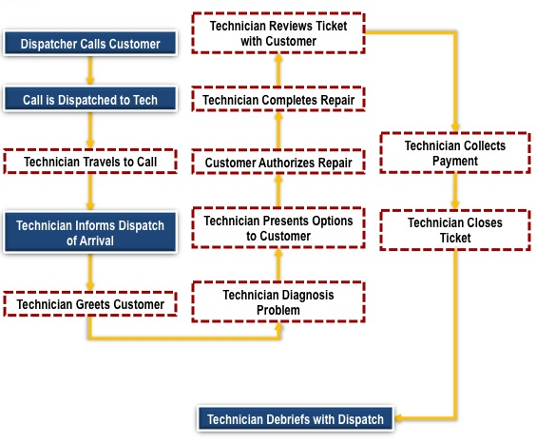

Maintaining the dispatch board: (Overview)

- Create a schedule and routing plan for each technician
- Dispatch service/maintenance technicians
- Monitor technician performance
- Maintain ‘on call’ schedule for after hours

Creating a schedule and routing plan
Geography
Keep technicians in a tight geography (zone) whenever possible to improve efficiency and reduce fleet expense.

Boundaries
Some companies establish boundaries for their immediate market place and make provisions for servicing outlaying areas

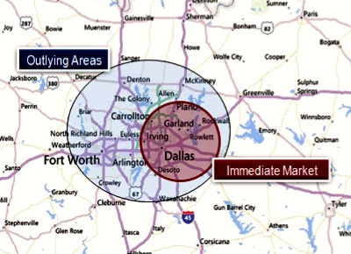

This strategy works well for smaller Service Departments serving a primary market while developing outlying areas. Often times, these companies will charge a higher initial service fee to accommodate for the additional travel in the outlying area.
This format makes it easier to set up and manage the schedule. The goal should to be to keep the technicians calls close or in the most efficient “pattern” or “cluster “as possible to minimize drive time and improve overall efficiency and productivity.

Zoning
Companies serving a larger market area must consider zoning techs to minimize windshield time.

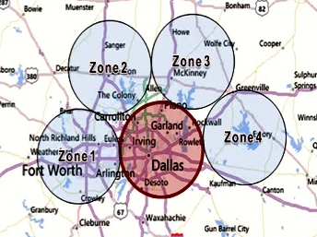

The strategy here could be:
- Assigning a Technician to one or two Zones
- Insuring that a Technician has at least two or more calls within the same zone or within a reasonable distance (less than 10 minute drive time) from call to call when ever possible
Zoning also makes it easier to efficiently route Technicians in a fashion that allows for dropping off paperwork to the office.
Schedule calls in a fashion that brings them closer to the office as the day progresses, Schedule routes where technicians can “Hand Off” paperwork to Salespeople, other Technicians, Mangers or any other support staff that might be close at the time.

Green Field
Some companies will acquire another company or start a ‘green field’ in an adjoining market:
CSR & dispatching functions can be performed from home office to control the quality of customer service and to reduce operating costs
Success lies in the execution.
- It can be brilliantly successful
- But can also fail miserably

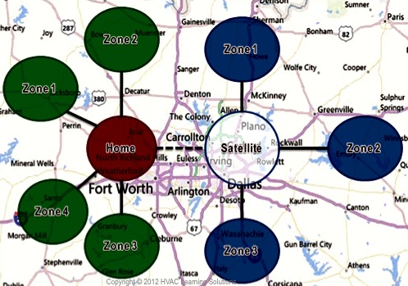

Hub and Spoke
- Each spoke is a production unit, typically with about 4 or 5 service technicians
- CSR, dispatching, and administrative and management functions are performed from the hub
- Allows company to create footprints that are easily replicated and yet controls the quality of customer service
- There’s the sake of argument about reducing brick & mortar expense
- Again success depends the execution

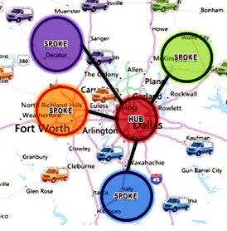

Creating a schedule and routing plan
Technician skill sets

The biggest challenge to dispatching is sending out a technician qualified for the particular call, handling priority calls, and yet keeping technicians in a tight geography:

Not all technicians have the same technical skill sets; this is particularly true for a growing service department or for companies with maintenance technicians

Sending technicians, who lack the technical knowledge to successfully troubleshoot the particular type of problem, negatively affects productivity, often causes callbacks, and can create a poor customer experience

Utilize a technician skill chart to help dispatching identify individual technician skill sets. Some dispatching systems incorporate a similar function into their software. Plotting technician skill sets also help in creating training plans for individual technicians

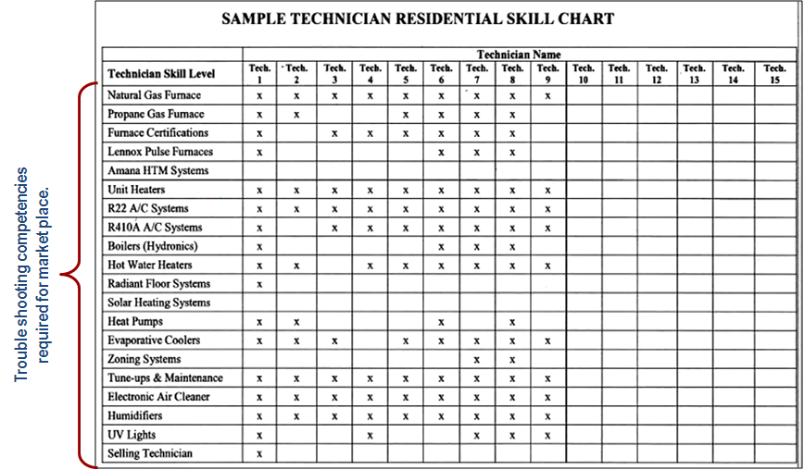

Creating Your Own Technician Skill Chart

- Identify the types of equipment and technology used in your market place (i.e. heat pumps, oil heat, etc.)
- Identify what skills are needed for each type of equipment/technology
- Identify those technicians who are competent in those skills
- Develop a training plan for techs to learn these skills by category
- Incorporate an internal certification process where technicians demonstrate the use of these skill sets
- Once a technician is certified for the particular type of equipment/technology, this is noted on the chart and the tech is available for dispatch

Technician Soft Skill Considerations in Dispatching

- For Maintenance Agreement renewal situations, send out technicians who reinforce the value of owning an agreement and are better at renewing them
- If company utilizes dedicated selling technicians, use them on calls where the equipment is older (both maintenance and demand service)
- If technicians do not sell, send techs that are better at converting into sales leads on demand service calls where equipment is older.

Creating a schedule and routing plan
Customer priority

- Send qualified technician to each demand service call (Consider both technical and soft skill competencies).
- Adapt routing during the day giving priority service for customers with Maintenance Agreements and to call priorities.
- Call customer next in line prior to dispatching technician to let them know the technician is on the way and to confirm someone is home

Example call priority:

Call Prioritization: Non functioning systems
Priority 1:
- Equipment over 10 years old
- Our installs under warranty
- Agreement customers
- Health related issues
Priority 2: Equipment (7-10 years)
Priority 3: Equipment under 7 years (Active customer)
Priority 4: Equipment under 7 years (Non active customer)

Dispatching service/maintenance technicians

Time stamp dispatch time, arrival time and completion time

- Allows analysis of company travel times
- Often ties directly to payroll for most software
- With mobile dispatch time stamping becomes the technician responsibility
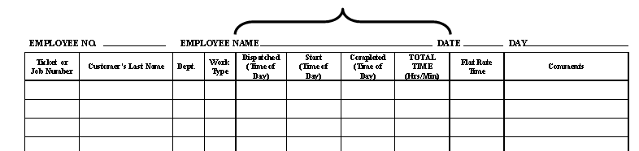

Note: Some companies capture time stamps via time sheets

Provide technician with information needed on each service call:
- Customer information
- Call Code (flat-rate, time & material, PTU, callback, etc)
- Description of problem or problem code
- Equipment service history
- Age of equipment
- Maintenance Agreement status
- Warranty or Extended Warranty status
- Method of payment
- Special instructions
When a repair requires a non-truck stock part, follow company policy

Debrief technician at the end of call to summarize details of call
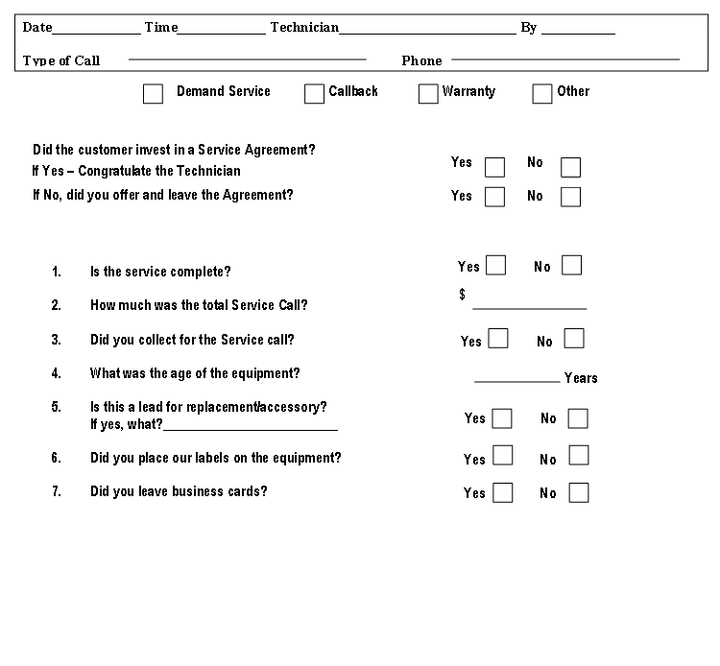
Debriefing Technicians after every call:
- Holds everyone (especially Technicians) accountable to process.
- Quantifies all information necessary to update daily results
- Clearly communicates the status of each call in support of efficient follow up and follow through.

Monitoring technician performance:
- Update goal boards weekly
- Provide management with daily reports

KPI’s (Key Performance Indicators) for a Service and Maintenance department typically fall under these categories:

Completed Calls
Typically 4 per day per Technician MINIMUM and 6 to 7 per day per Technician during HIGH DEMAND season

Revenue
Revenue expectations are generally between $700.00 to $900.00 per day per Technician.
This number is based upon three things:
1. Revenue necessary to accomplish revenue benchmarks set forth in the business Plan.
2. Insuring that the daily revenue reflects no more than 22% blended labor to revenue.
Example: lets suppose you have three Technicians. Add their hourly wages and divide by three to get their “Blended Wage”. For our example, lets use $17.00.
The benchmark for service labor is no more than 22% of sales.
So, Take $17.00 ÷ 22%= $77.25. add 10% to accommodate for inefficiencies, warranties and recalls: $77.25÷ .9 = $85.80.
$85.80 x an 8 hour workday = $686.40 (700.00) minimum revenue
per Technician per day.

3. Production capability of the Service team.
At an average 4 to 6 call per day and assuming 20 working days per month, do you have enough Technicians to accomplish the revenue goals based upon the above criteria?

Agreement Sales
40 to 60% of all Service or Open Tune up calls should convert to a maintenance agreement.

Replacement Leads
8% to 12% of all Service, Maintenance or Open tune up calls should result in a replacement Lead.

Productivity Ratio
A blended technician wage (in our example) of $17.00 per hour divided by .22 (Service Labor should not exceed 22% of revenue) = $77.25. Add 10% to accommodate for inefficiencies = $85.50. $85.50 is the minimum daily benchmark.
Divide the total revenue billed from a Technician by the Total amount of hours claimed on their time sheet or Time stamping to arrive at their productivity number. (Example: 10 hours divided into revenue of $650.00 = $65.00. Well below the $85.00 benchmark. That truck lost money that day. Whereas 10 hours divided by $895.00 = $89.50. Well above the $85.00 benchmark. That truck made money.

Efficiency Ratio
Assuming you can track how many hours were billed out and your service pricing is set properly, the Efficiency ratio is a great way to measure daily performance. Hours Billed divided by Hours claimed on time ticket or stamping should not be below 75%.
Example: technician 1 billed out 6 hours and claimed 8 hours on his time sheet. 6 divided by 8 = 75%. Assuming Service pricing is set properly, that truck made money that day. If the ratio was below 75%, I wouldn't have been a profitable day.

A Service Goal board would typically be organized like this:

(Daliy) KPI’s Benchmark Actual

Dispatched calls 20 22

Revenue $3,200.00 $3,000.00

Agreement Sales 8 9

Replacement Leads 2 3

Productivity Ratio $80.00 $73.00

Efficiency Ratio 75% 70%

A second board reflecting the Moth to date and Year to date is highly recommended also, tallying the results n color where RED represents missing the Benchmark and GREEN represents beating the benchmark adds a sense of urgency.

On-call process

Responsible, customer focused Service Companies make themselves available for their customers 24 hours a day, 7 days per week. 9 to 5 “Normal Business Hours” for Demand service isn’t very effective therefore making your Services available to customers when they need you is vital to the long-term success for any Retail Service organization.

Generally speaking, the General manager or Service Manager should develop the On Call rotation with input from the service team.

It is good practice, especially during “Code Red” high Demand months to implement an on call rotation for installation and sales since the company who gets there first during peak demand usually wins the job.

The Dispatching position is responsible to:
- Know the where-bouts of every critical position in the Company,
- Notifying all employees responsible for being on call of their schedule.
- Confirm in advance that they are aware.
- Resolve any conflicts within the on call rotation three to four weeks ahead of time.

Often times, there are conflicts with the posted schedule and the availability of the technicians. One method that works well is to:
- Post the on call schedule in advance (four weeks minimum if possible).
- Allow all on call technicians the opportunity to review it.
- Technicians should be responsible to negotiate switching schedules with one of their fellow technicians and notifying dispatch in writing three weeks ahead of time for the change.
(Make this a standard to avoid last minute disruptions)
- The acting service manager can review the request and either approve or resolve any issued at that time.
- Dispatch then makes the changes and distributes the revised on call rotation to everyone involved.

In the event that a technician can’t resolve a scheduling issue (three to four weeks prior to the on call commitment), the ultimate resolution should default to the acting Service Manager.

It is a good idea to have an on call back-up support protocol as well.
Example:
Emergency call rotation escalation:
If an on call Technician has more than two emergency calls pending:
- Back-up Technician is alerted.
- On Call manager/Dispatcher is notified.
If the on call Technician and back up Technician both have two open calls:
- On call dispatcher or manager is alerted.
- All calls routed through the on call dispatcher or manager.
- Upper management notified of escalation.
Incoming call volume reviewed by upper management to determine if “code red status” needs to be implemented.

A good argument can be made for having the “escalation process” as the standard process for on call support as well as incorporating a second shift hybrid Call Taker/Dispatcher/Data entry support person. A second shift Call Taker/Dispatch/Data Entry position in conjunction with second shift Service and or Maintenance Technicians can propel a Service Business to the next level quickly.

