Dispatching 3

Dispatching processes

Scheduling For Efficiency – Man Day Guide

Dispatch One Call At A Time

Technician Not Having Necessary Part(s)

Warranty part return policy

Open Service proposals:

Technician Can’t Solve Problem

Over 10 Program

Scheduling Precision Tune-Ups for Maint. Agreements

Technician Debrief

Scheduling For Efficiency – Man Day Guide

Remember the objective of the call is not to rush through as many as possible; the purpose is to build upon the relationship with the customer:

* Typically dispatch to the first call, then run 2 additional in the morning and 2 in the afternoon
* When performing PTU’s, try to keep the technician in the same zip code for the day or at least in adjacent zip codes
* Avoid performing tune-ups on overtime

A residential service technician generally can handle

4 to 6 service calls per day:

* This of course depends upon the type of repairs
* Service dispatching must balance not only geography, but also technician capability
* Also making sure to send out a technician with the right parts
* Overtime does play a part - Need to use your most productive technicians in overtime situations

For commercial service, the dispatcher must look at the hours scheduled for each service agreement

Many commercial maintenance calls on service agreements can take a half-day or even multiple days to complete

To re-emphasize, the dispatcher’s mission should not be to jam as many calls in a day as possible:

* Must allow time for technician time to perform the repair as well as time to debrief customer (customer relations)
* Rushing technicians increases stress and can cause callbacks, poor morale, etc.
* Rushing the technician does not allow for ‘Healthy Air Inspections’ and increased IAQ sales

Yet, the dispatcher must be aware of situations where the techs may be dragging out calls, or even worse.

The most successful dispatchers perceive their role as helping technicians succeed

Dispatch One Call At A Time

When you hand out the day’s schedule to techs:

* They tend to adjust the pace accordingly
* With a busy schedule, technician tends to rush through the calls and customer service suffers
* With a less busy schedule, technician tends to slow down and the company loses flexibility to add calls during the day
* There’s also the risk technicians will swap calls and the dispatcher loses all control
* This is one of the reasons most companies hover at a 50% Efficiency Ratio instead of 75% or better

For all of these reasons, it’s better to dispatch calls one at a time.

It does make the role of dispatching more hectic, but it’s the only way to maintain control over the service operation

Mobile Phone Applications

* Mobile phone applications virtually bring many of the dispatch functions directly out to the technicians SMART phone or IPad
* Calls are dispatched out to the tech
* Tech does time-stamping
* Tech literally closes the ticket in the dispatch system and even posts to the accounting system
* Most mobile dispatch applications allow for either batching calls to the technician or dispatching one at a time. For all the reasons listed previously, dispatching one call at a time is still preferred

**First Call of the Day Considerations**

Is it better to dispatch technicians from their home or from the shop?

**From Home:**

* Clock starts when the tech arrives on the first call; Technician may be able to get additional calls in for the day; Consequently, reduces labor cost and increases revenue
* Allows company to zone technicians, particularly where company serves a large geography
* However, allowing employees to use a company vehicle to drive home, could affect insurance rates
* Need very firm policy on use of company vehicles – do not tolerate abuse
* Need processes to restock vehicles and to collect paperwork. Daily replenishment is preferred:
* Many companies route tech back to the office during the day, or use parts runner
* Need to get the technicians in regularly for events such as department meetings or training so they don’t feel like the Lone Ranger

**From Shop:**

* Clock starts when the tech departs the shop. Generally less efficient than dispatching from home.
* However, does provide an opportunity for daily service department meetings to:
  + Review department performance for previous day
  + Motivate techs for the day ahead
  + Conduct training
* It can be a challenge getting technicians dispatched from the shop in a timely manner in the morning
* Parts replenishment (use technicians bins)
* The need for special instructions (document rather than relying on verbal instructions)

Technician Not Having Necessary Part(s)

Implement a truck replenishment process that maintains a standardized truck stock for the majority of repairs:

* Remember the 80/20 rules: 80% of parts used on a routine basis come from 20% of the stock that could be purchased.
* Review your frequent parts purchases for the past 12 months. Look for the most common items.
* Consider seasonality of shelf life of parts. Think of truck stock as dollars sitting on a shelf. Damaged stock is like burning dollars. Also, the longer it sits, the more likely it will be damaged or obsolete.
* Conduct truck inventory counts regularly; There must be consequences for part shrinkage
* Avoid sending technicians to supply houses for parts. In addition to adding to labor costs and hurting efficiency, it limits the number of calls a tech can run and consequent revenue

For non-truck stock repairs, technician contacts dispatcher for further instructions on how to proceed:

* Is the part in stock in the warehouse?
* If so, can arrangements be made to get part out to location?
* Depending on part availability, should technician be sent to next call and rerouted back once part’s delivered?
* If part must be ordered, technician provides:
  + Part description
  + Part number
  + Make/Model Number/Serial Number of equipment

Any other pertinent information

Customer contact information to schedule return

If sending a tech to a supply house can’t be avoided, be sure to require Purchase Order number

Warranty part return policy

The objective of warranty parts process is to insure that the Company receives compensation for having to replace a defective part under warranty. This assumes that the defect had nothing to do with improper installation or neglect.

Here is a brief overview of a Warranty parts process:

Rationale

It is to everyone’s advantage that we do this. Call-Backs cost the Company a lot of money and resources. The labor for these call-backs, in accounting sense, non-productive. It makes Technicians and the production force look bad. When we reclaim revenues for call-backs that are no fault of our own, we are all better off.

Method:

Develop a separate invoice for any warranty call.

Check the appropriate box that indicates weather the call was :

* Installation teams recall
* Service man recall
* Defective warranty part

Document the complete customer information

Make Model and serial of equipment

Description of part (If applicable)

Make model and serial of replacement part

Hours spent repairing defective unit

The yellow copy of the Warranty invoice is to be attached to the defective part

The defective part is to be:

Turned in with all paperwork, to standard.

Daily, the Opening dispatcher will review all warranty invoice numbers and compare to all returned warranty parts.

If a Technician replaces any warranty part and does not return the defective part to the office for processing, the technician may be billed for the balance of the unrecovered warranty refund.

Open Service proposals:

It is advisable that a 3 Tier Service Proposal for each Demand Service, Open Tune up and Maintenance call. Often times, the Technician will recommend additional work to bring the system up to proper operating standards or to address other needs in a home conversationally.

Often the customer will decline the additional work and proceed to do the minimum work necessary to restore operation and often times the Technician will not document the additional services or work recommended.

In this scenario, not addressing all of the issues could be problematic for the customer in the near future. If they have a problem as a result of not accepting all of the Technicians recommendations, they might feel entitled to a FREE repair under the mistaken premise that the technician didn’t do their job properly to begin with.

Here is an example of a Service Proposal:



Proposal #1 would be the minimum required to restore safe operation.

Proposal #2 would be everything it would take to bring the system up to proper operational standards including replacing any component the appears to be wearing out.

Proposal # 3 would address anything else the customer might want such as reduced allergy triggers, Better Humidity Control, Reduced dust circulation, Minimizing hot and cold spots, Reducing drafts, reducing noise or system design retrofits.

Developing the habit of following this process on every call not only clarifies a-lot of misconceptions; it also lends itself to building a pipeline of follow up opportunities during the shoulder or slow months.

Technician Can’t Solve Problem

This situation should be avoided if at all possible, but if it does, decide:

* Keep technician on call and schedule another one to join
* Dispatch technician to next call

Technician Selling & Sales Lead Turnovers

There are many variations of processes supporting technician sales lead turn-overs. From a dispatch standpoint, here are things to consider:

* When using a dedicated selling technician (senior tech), route this person on both maintenance and service calls where the equipment is old for the market:
  + Technician turns this into a sales lead/presentation
  + Technician notifies dispatch that call has turned into a full blown sales presentation. Dispatcher adjusts routing schedule
  + Technician debriefs Dispatcher/Lead Coordinator on sales presentation outcome
  + In repair situations where the customer declines the equipment replacement option, technician proceeds with repair
* When technician sells an accessory, notify dispatch of pending installation
  + Dispatcher adjusts routing schedule accordingly
* On service calls where technician turns-over a sales lead (i.e. major repairs like a compressor failure or bad heat exchanger):
  + Technician calls office and is dispatched to next call
  + Comfort Advisor is dispatched to sales appointment
  + If customer declines replacement option, dispatcher reschedules technician to complete the repair

Over 10 Program

Here is an example of a very successful approach to Lead Generation and how it affects dispatch:

* Technician is dispatched to service/maintenance call.
* Technician identifies if this is a replacement opportunity within the first few minutes of call.
* Technician calls Dispatcher/Lead Coordinator to see if a Comfort Advisor is available.
* Technician continues with diagnostic on service call or system evaluation on maintenance call.
* Technician presents findings to customer and counsels on repair versus replace options. Technician asks if they want to explore their replacement options
* If so, technician calls office to dispatch Comfort Advisor; when Comfort Advisor arrives:
  + Comfort Advisor greets customer and asks to meet with technician
  + Technician alerts Comfort Advisor of any concerns and covers the details of the repair and corresponding costs
  + Comfort Advisor meets with customer and goes over repair versus replace options
  + If customer is interested into looking at replacement options, Comfort Advisor turns this into a sales presentation
* If not, technician continues with repair or service;

Here are some results seen with this type of program:

* 20% of all service/maintenance calls turn into opportunities
* 75% of all opportunities have a Comfort Advisor dispatched
* 50% of all Comfort Advisor dispatches turn into sales leads
* 65% of all sales leads result in a sale
* There’s also the opportunity for ‘back door” sales

Scheduling Precision Tune-Ups for Maint. Agreements

It’s obvious that you want to schedule PTU’s for slow times of the year. However, getting all PTU’s completed before the cooling or heating season hits can be a challenge, particularly if the company does not have maintenance technicians. Here are insights to consider when scheduling:

* Do cooling tune-ups below 75 degrees
* Get away from using the term pre-season:
* It’s either a cooling or heating tune-up
* It can be scheduled pre-season, post-season, or even mid-season depending on the work load

Create a company mindset that tune-ups can be performed throughout the year

Utilize dedicated maintenance technicians:

* Utilize all of your technicians to get your Maintenance Agreements taken care of in the valleys
  + However, if demand service becomes an issue, you still have maintenance technicians to meet your precision tune-up commitments

Getting with Maintenance Agreement customers to schedule a PTU can be a headache. Possible solutions include:

* Set next appointment while performing a Precision tune-up
* Leave customer a reminder card for next appointment, just like the dentist
* Collect customer’s email address and confirm next appointment electronically
* Call customer prior to appointment date to confirm appointment once again

Utilize a good dispatch system to identify the number of PTUs that are due in the upcoming month and consequent manpower requirements

Technician Debrief

In addition to closing the ticket and time stamping, having technicians call dispatching after call is complete offers other advantages.

*Collecting Information:*

* If the software system can’t provide daily performance measurements (dashboard reports) key information can be collected in the debrief
* What type of call was this?
* Did customer invest in a Maintenance Agreement?
* Is this a completed call?
* What was the ticket amount?
* What was the equipment age?
* Is this a lead for a replacement/accessory?

*Confirming processes were followed:*

* *Did you collect?*
* *Did you place labels on equipment?*
* *Did you go over labor warranty information (repair situations)?*

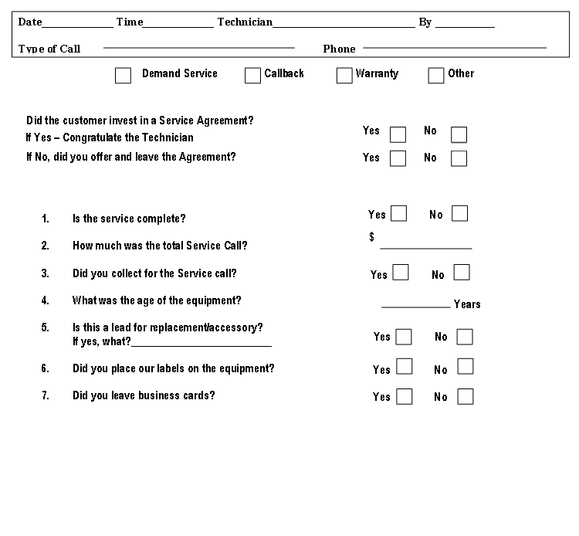

Dispatch Steps

1. Prepare preliminary technician routing for the next day
2. Check status of parts on order and schedule accordingly
3. Check status of all other ‘Incomplete Calls” and schedule accordingly
4. Dispatch technicians to first call of the day per company policy and time stamp. (Typically, technicians will get their first calls the evening before upon completion of their last call.)
5. Time stamp technician arrival time.
6. Check in with Technician 45 minutes into the call for call update. This will give you time to adjust the schedule accordingly.
7. Technician proceeds with repair or maintenance. Some companies have their techs notify dispatch when the call is nearing completion (while they are filling out paperwork).
8. Dispatcher calls next customer in line to notify them the technician is on his/her way.
9. Technician calls dispatch to close call. Dispatcher collects information from technician debriefs.
10. The next call is dispatched to technician. Dispatcher completes time stamping.

*NOTES:*

*Typically the travel and diagnostic time takes about an hour*

*If the technician can’t diagnose the problem in a set time frame, company policy should dictate a request for assistance*

*Most service windows are set in 2 hour increments inclusive of travel time*

*If repair(s) are going to go beyond this window, technicians should notify dispatcher*