Pre Call Virtual Mailer and
Preparing for the call

Tom Wittman
Advocate for the Success of Contractors
HVACCoachingCorner.com
317-750-1607

Produce a link to a short 40-second
(Or less) “What to expect video””

Video Script

HI, (Name) here. Excited to be helping you design your new system. I’ve attached a link to our meeting below. You might want to be thinking about areas of your home that might be difficult to heat or cool, system noises or anyone struggling from asthma, hay fever or respiratory issues. We might be able to reduce some of those symptoms. A list of photographs we would like to review before our visit is included in this e mail. If you are uncomfortable taking any photos or if the areas are not accessible, no sweat, we can complete the budgeting process with minimal photos about 80% of the time. Looking forward to working with you! If you have any questions, feel free to text email or call.
Take Care!

Add the link to your e-mail - text “Introduction video”

From: Tom Wittman <coachtomw@gmail.com>
Sent: May 3, 2020 5:51 PM To: John Smith JS@gmail.com
Subject: HVAC Design Meeting

Short Video regarding our HVAC Appointment
List of photographs we would like to review with you.
Thermostat (s) - Indoor Unit
- Front – Right – Left – Back Flue pipe at furnace (If gas – oil or Propane)
- Filter rack - PVC Drain from the A/C
- Connections to the Ductwork at the furnace
- Nameplate with serial number (if accessible)
Outdoor Unit
- Front – Right – Left – Back
- Copper lines coming out of the house and into the unit
- Electrical Connection
Closets – Gates – Doorways Width and Height

Join Zoom Meeting 6:30 PM
https://us02web.zoom.us/j/2023148348

Include a short list of
Photo’s you would like to see

List of photographs we would like to review with you.
Thermostat (s)
Indoor Unit
- Front – Right – Left – Back
- Flue pipe at furnace (If gas – oil or Propane)
- Filter rack
- PVC Drain from the A/C
- Connections to the Ductwork at the furnace
- Nameplate with serial number (if accessible)
Outdoor Unit
- Front – Right – Left – Back
- Copper lines coming out of the house and into the unit
- Electrical Connection
Closets – Gates – Doorways
- Height and width of any Doorways – Gates – Closets – Attic access or Stairs we might encounter when installing your system.

Include a Link to the Zoom Meeting

Zoom Link
Date and Time
Join Zoom Meeting 6:30 PM
https://us02web.zoom.us/j/2023148348

Have a diagram of different system Configurations Accessible for your Zoom Meeting if necessary
(Down flow)

(Up flow)

(Horizontal)

Prepare your Heating and Cooling Load Calculation with CoolCalc.com

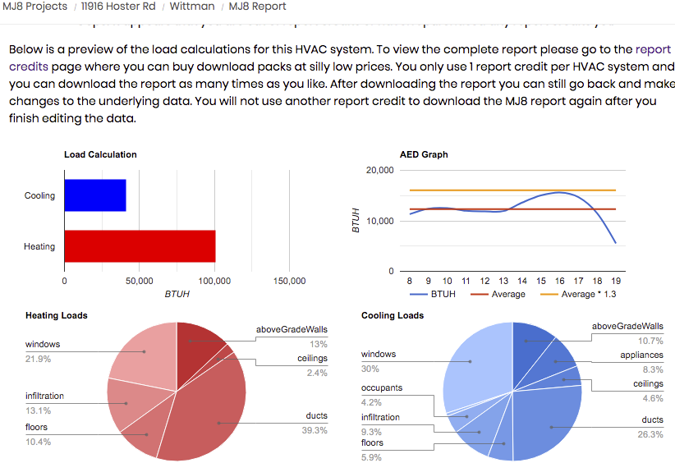

Prepare your Photo’s

Photos

A. If they are sent ahead of time, Load all photos and prepare your Presentation.

B. If Customer is to be your eyes and ears, email or text the phone a link and direct them where to point the camera & take screen shots.

C. If the photos are not available, be prepared to establish budget ranges and a quick on site to finalize the price.

Prepare your Presentation

