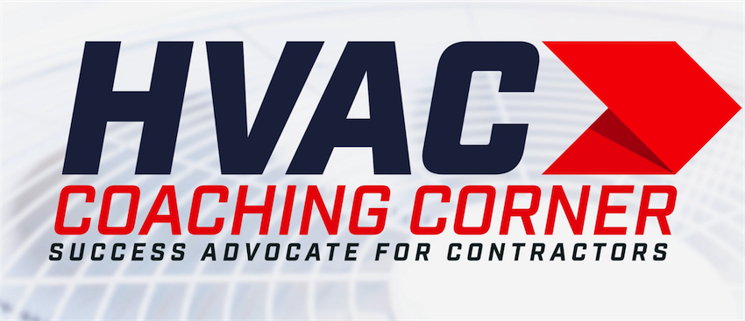
Virtual Closing Process

Tom Wittman
Advocate for the Success of Contractors
HVACCoachingCorner.com
317-750-1607

I need to think it over

Are you comfortable with the System You Chose?

Does the additional work make sense to you?

Would you trust us with the project?

Is it the price?

I need to think about it because of the Price.

What were you hoping the price would have been?

I was hoping the price would have been $10,000.00 (1 of 2)

If we could re-design the system at a price closer to the $10,000.00… Would there be any reason not to move forward?

I was hoping the price would have been $10,000.00 (2 of 2)

How were you planning on paying?

I am going to pay cash

A lot of our customers use that as a down payment and finance the rest. Your monthly payment would be between $$$ and $$$ to get the system I believe you really want. Would you like to look into that? or would you rather have me re design the system?

I’m not sure how to pay for it

If you had a way to pay,
Would there be any reason not to schedule the work?

I can’t afford that

If we could make it affordable, would there be any reason no to move forward?

I’m going to do it later

How soon will you be moving forward with the project?
(6 Months)
What’s going to be different then?
(Save the money - Bonus —)
If you had the (Bonus - Money) now, would there be any reason not to schedule the work?
We have a program where you can have the system now and delay payment for (6-12) months.
That will work right?

I need to talk it over with my spouse

If (He / She) were here, what would their biggest concern be?

Would it be possible to Zoom her into the conversation?

Is it the Price? (Customer says)
“I’m not sure”.

Often times when my customers aren't sure about the price, Its usually one of two things:
You want to do it but your not sure how to pay for it
Or
Your not sure if you want to spend that much money.
Which one are you?

I’m not sure how to pay for it

If you did have a way, would there be any reason not to move forward?
No

(Solve the problem)

We have some great financing options. A job like this would have a monthly payment of (A - B - C) Which one works best for you?

I’m not sure if I want to
pay that much

What I’m hearing you say is…
You want to make sure your not overpaying for the work…
Is that right?

I want to make sure I’m not overpaying for the work

If you were Confident you weren’t overpaying, would there be any reason not to move forward?

If I were certain I wasn’t overpaying, I would schedule the work

If you bought a Computer and found a crack in the screen, Would you expect the Department Store to exchange the Computer or give you a full refund? (Yes)

I would expect that too… and that’s exactly why we offer a no questions asked return policy for our customers. If your not happy with your new system, we will do whatever it takes to make it right, exchange it for another one or refund your money for the first year of ownership.
Our Customers appreciate the fact that we take all of the risk in doing business with us. I have an opening next week on Wednesday or Friday. What works Best?

The other price I have is $3,000.00 less than yours

Our price includes everything you are getting with your new system, so does theirs. If there is a $3000.00 difference, there’s probably some Gaps in what your getting.

It would be my pleasure to do a comparison of their proposal with ours to find out where the gaps are.

I don’t want to see or know who the other proposal is from. If you could simply look at their proposal and answer a few questions We can complete the comparison so you can make a more informed decision.

I’m getting Other Bids

What were you hoping to learn that we haven’t
already discovered?

I’m getting other Bids
to compare prices

If you were sure you weren’t overpaying, would there be any reason not to move forward with the work?

I always get three Bids

( ) and I do the same thing. Mainly to make sure were not being taken advantage of.
Can you remember a time when you bought something of significance and regretted making the purchase?
Tell me about that….
Were you able to get your money back for the purchase?
We think that’s the right thing to do for our customers.
If your not happy with your new system, our Company or for any reason, we will do 3 things:
1. Do whatever it takes to make it right
2. Exchange the new system with another system
3. Refund your money, no questions asked for up to 12 months.

I’ll be finished collecting the other bids in three days

That Soon?

What I’m hearing you say is you want to make sure your not overpaying for the work, is that right?

I’m getting other Bids because I don’t want to overpay.

If you were sure you weren’t overpaying, would there be any reason not to move forward with the work?

If I were sure I wasn’t overpaying I would move forward.

If you bought a Computer at a department store took it home and found a crack in the screen, would you expect the Department Store to exchange the Computer or give you a full refund? (Yes)
I would expect that too… and thats exactly why we offer a no questions asked return policy for our customers. If your not happy with your new system, we will do whatever it takes to make it right, exchange it for another one or refund your money for the first year of ownership.
Our Customers appreciate the fact that we take all of the risk in doing business with us. I have an opening next week on Wednesday or Friday. What works Best?

I’m getting Other Bids Because I always get three Bids

Our price reflects everything your getting with your new system. So will theirs. If you find another Company promising to do what we propose to do at a cheaper price, there is likely some GAPS in what you’re getting.
How soon will you be finished with your research…
It would be my pleasure to do a comparison of their proposal with ours to find out where the gaps are.
I don’t want to see or know who the other proposal is from. If you could simply look at their proposal and answer a few questions We can complete the comparison so you can make a more informed decision. What day and time would be good schedule the comparison?

I’m getting other Bids to compare different models

All major HVAC Brands have similar features. 70% of how well a system performs relies on the competency of the system designer - Installation Technicians skies - and the support of the service department. 30% of how well the system performs relies on the Equipment manufacturers Quality - Customer experience focus - and training support. Thats why we partnered with (Brand) If there is an issue we can’t resolve, they will fly a manufacturer expert out and resolve the issue.

That’s exactly why we can safely offer a no questions asked return policy for our customers. If your not happy with your new system, we will do whatever it takes to make it right, exchange it for another one or refund your money for the first year of ownership.

Our Customers appreciate the fact that we take all of the risk in doing business with us. I have an opening next week on Wednesday or Friday. What works Best?

