Climate Care CSR Flashcards

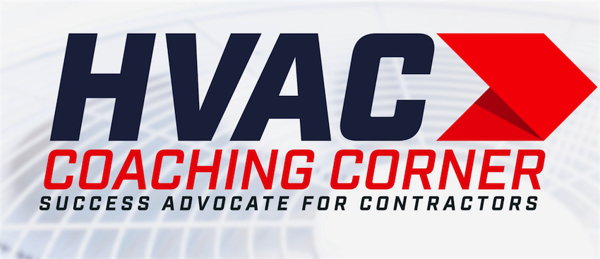
Customer Service Representative

Tom Wittman
317-750-1607
www.HVACCoachingCorner.com

What are the Incoming Call Benchmarks?

- Answer Phone Promptly.

- Speak Clearly with a Smile in your voice.

- Maintain a Can Do Attitude

- Focus on what you Can Do not what you Cant.

- Become the solution

What are the Call Conversion Standards?

- Listen to understand
- Empathize
- Repeat the request
- “I can Help you with that"
- Book the Call
- Plant the Seed
- Isolate “Is there anything else I can help you with?"
- Resolve
- Follow Up

Incoming Service – Maintenance or Replacement Sales lead
(Introduction)

- Thank you for calling ______________.
- My Name is _______ ________ how can I Help You?
- (Listen intently and respond)
- What’s going on? (Listen)
- (If there is an issue ask)How long have you had this issue?
- (Listen intently and respond) That must be…(Frustrating...)
- We can Help you with that. Just need some information

Capture or Verify your
(Customers Information)

- What is the best phone number to reach you at?
- Are you the home Owner?
- First and Last name?
- Address?
- E Mail?
- How old is your system?
- How did you hear about us?

Scheduling Service Calls:
High Demand Season

Right now, we are taking care of our Agreement customers, and high-risk situations. What I can do is put you on our standby list and route the next available Technician to your home.

(If system is 13 yrs. or older) We currently have 2 - 3 calls ahead of you and will call as soon as one of our Technician free up. Lets get you on the Schedule.

(If system is 7 – 12 yrs. old) We currently have 4 - 6 calls ahead of you and will call as soon as one of our Technician free up. It might be late this afternoon or possibly sometime tomorrow. Lets get you scheduled.

(If system is 1 – 6 years old) We currently have 7 - 9 calls ahead of you and will call as soon as one of our Technician free up. It might be late tomorrow or possibly the following day. Lets get you scheduled.

Setting a Demand Service Call

We will send a Certified Technician with a Fully Stocked Service Van to your home and diagnose what it will take to restore operation.
Once we know what we need to do, Your Technician will explain what’s going on and give you a few options in getting your system operational.
Once it’s operational, we will check the entire system to make sure there aren’t any other issues.

The Diagnostic fee is $180.00. Be sure to ask your technician how to get a % discount off of the Diagnostic fee and additional discounts off repairs.

If we have the materials on the Service Van, we can restore operation on the first visit. If we need to order a part, our purchasing Agent will expedite the materials as soon as possible to complete the repair.
Just need a credit card number on file to process the appointment.
Is there anything else I can help you with while I have you on the Phone?

$180.00 to drive to my home?

Let me Clarify on what you are getting.
We will send a Certified Technician with a Fully Stocked Service Van to your home and
- Diagnose what’s wrong.
- Review what’s going on and give you a few options in getting your system operational.
- Check the entire system to make sure there aren’t any other issues.
- If we have the materials on the Service Van, we can restore operation the first visit. If we need to order a part, our purchasing Agent will expedite the materials as quickly as possible.
You will also have a one-year warranty on the materials and 30 days on the labor. Once we verify that we can support your type of system with 24 hour service, you will be eligible for 50% off the diagnostic and Discounts on repairs with the purchase of a Service Agreement.

Benefits of a Service Agreement

A Service Agreement will give you:

- 24 hour access to repair services
- off of Diagnostic fee’s
- Priority Demand Service Response (24/7)
- Significant discounts on repairs
- Two comprehensive system tune-ups during our slower months

Booking a New System Estimate

- Thank you for calling the Reiner Group.
- My Name is _______ ________ how can I Help You?
- (Listen intently and respond)
- What’s going on? (Listen)
- (If there is an issue ask) How long have you had this issue?
- (Listen intently and respond) That must be frustrating.
- We can Help you with that. Just need some information

Capture or Verify your
(Customers Information)

- What is the best phone number to reach you at?
- Are you the home Owner?
- First and Last name?
- Address?
- E Mail?
- How old is your system?
- How did you hear about us?

Set the Agenda

- When the CA arrives, they will ask a few questions to have a better understanding of what you want.
- Then they will evaluate your system and take a few measurements
- After they put your report together, They can review a few
- Systems with you until your comfortable with the price.
- This will take about 60 to 90 minutes. Are we ok on time?
- Will anyone else interested in the system and price be joining you?
- Is there anything else I can help you with while I have you on the phone?
- Thank you for calling. My name is ---------. If you have any questions or concerns, feel free to call me anytime.

How much is a new system?

Depends upon three things

- The size you home needs
- The system features you want
- And Additional work necessary for safe operation - Code compliance.

Once they finish the evaluation, they will review all options until you are comfortable with the price.

Just give me some sort of a ballpark price!

I can help you with that, I just have a few questions…

- What size is your HVAC system?
- How long is the copper lines from your outdoor unit to you indoor unit?
- Is your system gas - electric or oil?
- Up-flow Down-flow or Horizontal?
- Is the static pressure of the existing ductwork compatible for a new system?
- What size is the Breaker to the AC And the wire size?

It will take me about 30 minutes to spec out everything we need to establish some price points. Once they finish, we can review all options until your comfortable with the price.

What measures can you take to reduce stress?

- Don’t Worry about things you have no control of

- Set Goals

- Finish Unfinished Business

- Resolve Conflicts

- Take Care of yourself

- MINDSET

Irate Customers

- Never Blame the Customer

- Avoid Criticizing

- Maintain Self Control

- Put them in Control of the situation

- Follow Through

What are the Service Critical Performance Measures?

- Hours
- Revenue $1,200 per day
- Revenue per hour $100 - 135
- Completed Calls 4 - 7 per day
- Lead Conversion 10% or more
- Agreement Conversion 30% or more

